**Java String:** In Java, string is basically an object that represents sequence of char values. An array of characters works same as Java string. For example:

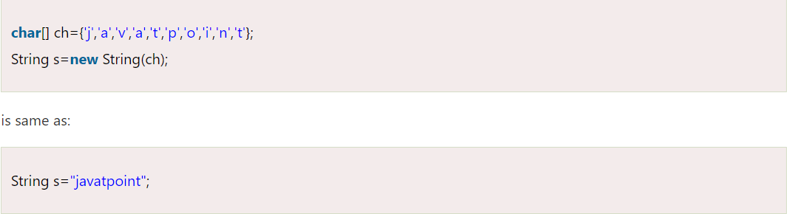

**How to create a string object?**

There are two ways to create String object:

**By string literal :**

By new keyword

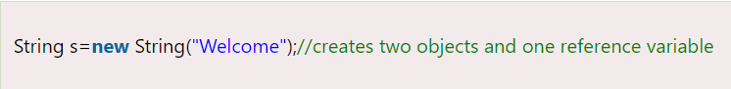

**Java String Example:**

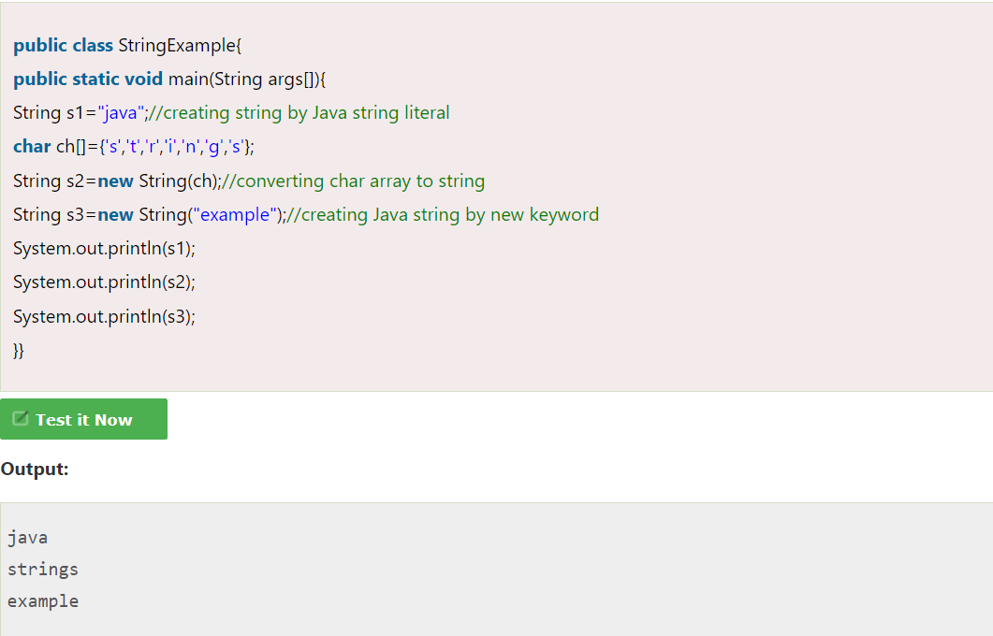

**Immutable String in Java:**

In Java, String objects are immutable. Immutable simply means unmodifiable or unchangeable.

Examples:

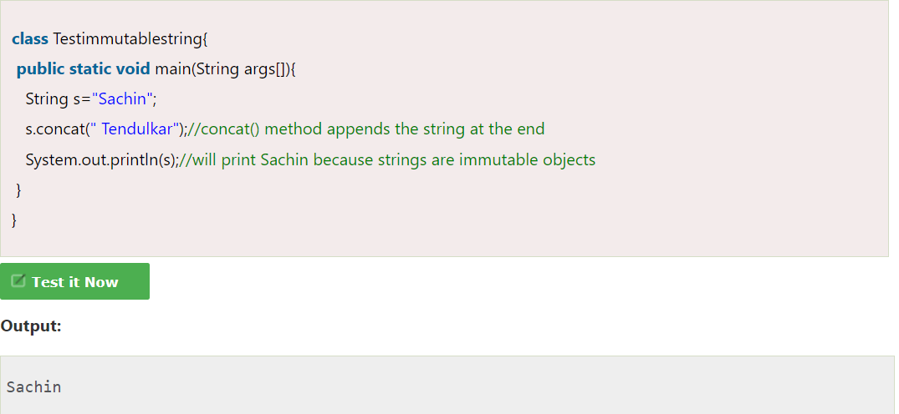

But if we explicitly assign it to the reference variable, it will refer to "Sachin Tendulkar" object.

